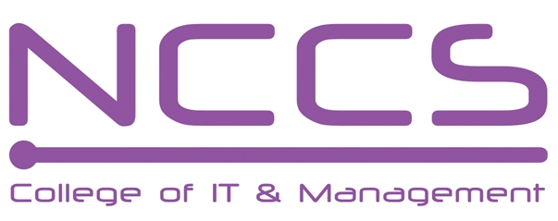
National College of Computer Studies
(NCCS-College of IT & Management)
Final Examination (2021)
BSc.CSIT/First Semester/ CSC-101 : Introduction to Information Technology

Candidates are required to answer the questions in their own words as far as practicable.

Full Marks: 60
Pass Marks: 30
Time: 3 Hours
Set B

Long Questions:
Attempt any two Questions: [2×10=20]
- Why system software is needed? What are the different types of operating system explain it?
- What is memory hierarchy? Explain different types of memory.
- Differentiate between centralized data processing system and distributed data processing system. State advantages and disadvantages of distributed systems.
Short Questions:
Attempt any eight questions [8×5=40]
- What is supercomputer? Compare mini and main frame computer.
- What are the different kinds of output devices?
- What is client server system? Explain briefly about different client server architecture.
- Differentiate between compiler, assembler and interpreter.
- Explain different modes of data transfer between CPU and I/O devices.
- What is register? Explain different types of bus.
- What is malicious software? How virus differs from worm.
- What is CAI? What are its advantage?
- Explain multimedia with its advantage and disadvantage.
- What is GIS? What are the components of GIS?

********

